Religious Education and Collective Worship Newsletter.
Spring Term.
Please see below the topics that have been covered in the different classes during this term.
Little Owls – Last half term we have gained knowledge and understanding about which places are special and why. We identified places that are special to us and reflected on what makes them special. We identified that a church is a special place for Christians and a mosque is special to Muslims. We explored the meaning of the word ‘holy’ and how it means something very precious to religious people. Our visit to All Saints’ Church allowed us to experience being in a holy place.
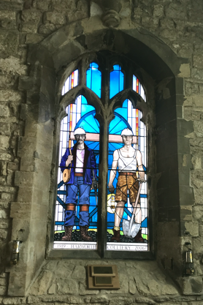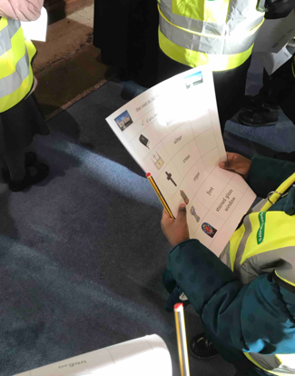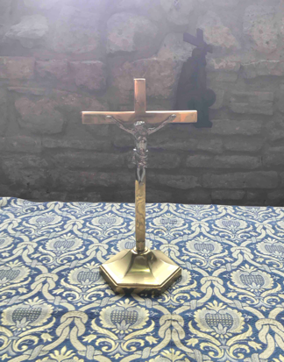

Elf Owls – We have been exploring different religious buildings, comparing features and relating them to special places we already know.  We have also been listening to and reflecting stories from the Old Testament and relating them to our lives. | Tawny Owls – We have gained knowledge and understanding into the religious beliefs that different religions have. We have gained the skills to reflect that different people may go on a pilgrimage, taking a journey to a spiritual place. A visit to Southwell Minster was an amazing part of our learning this half term.  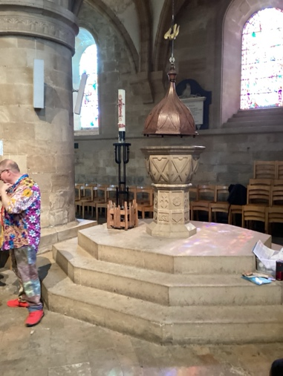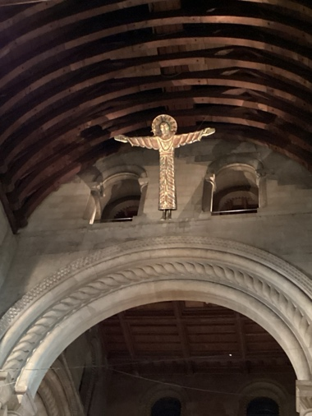
Snowy Owls – This term we have been exploring the Jewish religion and comparing their beliefs with those of Christians. We explored why the Torah is special for Jews and reflected on the importance of Shabbat. Then we started to explore the Easter Story and look at why Jesus gave up his life for others and why the Easter Story shows how salvation for all.  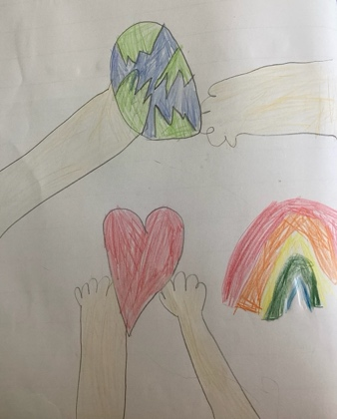  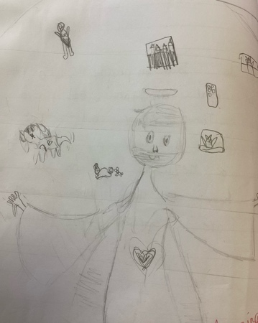 | Eagle Owls – Eagle Owls have been captivated by the story of Moses and the Exodus chapter from the Old Testament. Through engaging activities and stories the children have been exploring Moses' journey and reflecting on the powerful messages of faith and resilience. Also, Eagle Owls have explored the meaning of Easter and links with Faithfulness (our Christian value for the half term)
Barn Owls – Last half term we gained knowledge and understanding of how a Muslim prays and linking the similarities to how a Christian prays. We connected ideas and beliefs to what people in these two religions do. We responded thoughtfully to beliefs and ideas about prayer  that came up in the study. | Wise Owls – Last half term, Wise Owls studied Judaism before the second World War. We then went on to study how the World War impacted upon the Jewish religion, discussing the persecution that Jewish peoples faced under Nazi Germany laws. We further explored how Jewish people’s lives changed after the holocaust. In addition to this, we went on an educational visit the National Holocaust Centre, where we immersed ourself in ‘The Journey’ which made us appreciate the struggles faced by Jewish families whilst under Nazi Germany’s rulings.

Our Christian Value for this half term is Faithfulness
You can help your child to understand this value by discussing stories with them. Talk about the characters and their faith in what they were doing or what they wanted to achieve. Talk about your family beliefs and how faith can give us all hope. Discuss how we can have faith in one another and how kindness and trust are important.

.
“If you have faith as a grain of mustard seed, you will tell this mountain, ‘move from here to there,’ and it will move; and nothing will be impossible for you.” - Matthew 17

“Faith is taking the first step, even when you don’t see the whole staircase.” - Martin Luther King

