November Assemblies
During November at the class assemblies the children will be selling raffle tickets for a festive inspired draw. Tickets will be £1 per strip and drawn at the end of each assembly. So if you could please fetch along a pound (or two) for your chance to win. Happi group have put together a lovely box of treats to be won on each of the following dates:
15th November Wise owls
17th November Eagle owls
22nd November Tawny owls
23rd November Barn owls
24th November Snowy owls
29th November Elf owls
The BIG Christmas Draw
We are working on our annual Christmas extravaganza draw- the prizes are still being collected but so far up for grabs will be £600 worth of vouchers for Bawtry paint balling, a £50 voucher for the crown hotel bawtry, a flower arrangement from Maxines florist, a family pass for any Doncaster Rovers game, Doncaster knights goody bag, a month’s swimming lessons and goody bag from swim stars bawtry, a family pass to kidz hub soft play and a family tickets for the savoy cinema. We are still working on gathering prizes and tickets will be going on sale shortly.
Elfridges: 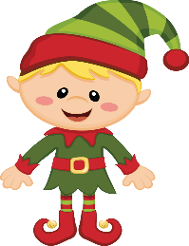
Thursday 15th December is our pop up shop Elfridges. The children love this event and will be able to purchase a maximum of two gifts- priced at £1 each for someone they love.
So please- raid your draws for any unused bubble baths, smellies, trinkets and if you have any spare wrapping paper or tape please send it into school. The Elves are also working hard on purchasing additional gifts to ensure the shop is well stocked.
Once again thank you for the continued support- and if you wish to join please come along to our next meeting (the date will be sent out shortly).

