ELFRIDGES IS BACK!
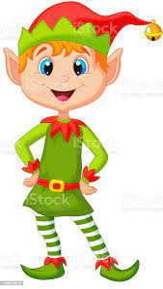
The Happi group are bringing back our Pop up Shop Elfridges this year.
Elfridges gives the opportunity for the children to do some Christmas shopping for someone they love.
Each gift is priced at £1 and children are allowed to bring in a maximum of £2 to purchase 2 gifts.
The “elves” will then help the children to wrap up their gift and write a tag- meaning they get the opportunity to surprise someone they love on Christmas day with a gift.
This is where we ask for your help. If you have any gifts at home from years gone by, such as bubble baths, smellies, trinkets, that are unopened and unused please send them into school. We also need wrapping paper, selotape and tags if anyone has any of those going spare too.
Please note- the happi group generally don’t make a large profit from this- and we also purchase gifts to make sure the shop has plenty of stock and choice. We can reassure you that any money that is raised goes straight back to providing fun events for our children. In previous years the children have loved shopping in Elfridges and relish in the opportunity to be independent in buying a gift for someone they love.
Thank you for your support (if anyone wishes to join Happi group- please do get in touch)

