Amaze. Achieve. Aspire.
Together
Harworth Church of England Diary Dates
Monday 10th February 2020.
We were delighted to receive a letter from the Minister of State for School Standards to inform us that we are in the top 1% of primary schools in the country. Please find the content of the letter below:

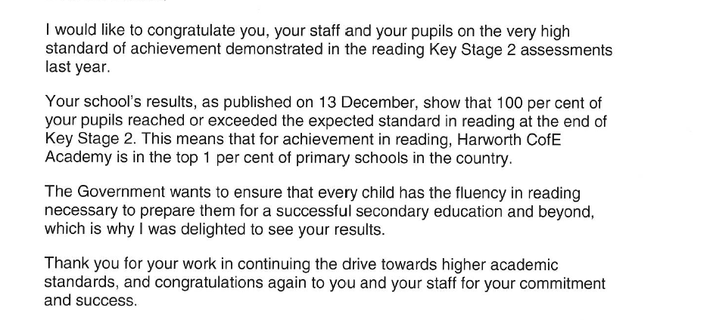

Mr Iles Funeral
The funeral for Mr Iles will take place on Tuesday 18th February at 4.30pm at Ollerton Crematorium, with refreshments afterwards at The ox at Wellow. The family have stated that it is an open invitation for all.

Friday 14th February – Stay and Learn for the next set of parents invited.
Break for half term.
Monday 24th February – Back to school.
Monday 2nd March – Parent drop in 3pm to 5pm.
Friday 13th March – Sport Relief day. Children can come to school in sports clothes. A small donation can be made to the charity if you would like to.
Tuesday 17th March - Barn Owls are on an educational visit to Southwell on this date.
Friday 27th March – Stay and learn for the next set of parents invited.
Monday 30th March – Snowy Owls are on an Educational Visit to Pink Pig Farm.
Thursday 2nd April – Easter coffee morning for Key Stage 1. A song from each class and coffee afterwards. All welcome.
Friday 3rd April – Easter coffee morning for Key Stage 2 (with a 'good bye and good luck’ to Ms Elkins). A song from each class and coffee afterwards. All welcome.

Break for end of term. Return on Monday 20th April.

