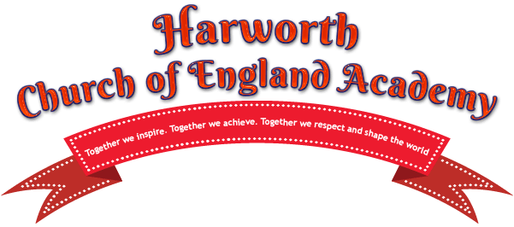

HAPPI GROUP SEPTEMBER 2019
Welcome to all parents, grandparents and carers to a new school year! We hope to be able to continue the success of last year- none of which would have been possible without all the support from yourselves, the children and the staff.
Last year we raised an amazing amount and were able to purchase a new laptop and sound system for the school, fund a music workshop for one of the classes, purchase bean bags for the library and class rooms if the children need somewhere quiet to relax, provide a pop up Christmas shop (elfridges) for the children to be able to buy (£1 a gift) and wrap gifts for the chosen loved ones to give on Christmas morning. We helped to develop the space at the top of the drive (please feel free to stand in here whilst waiting for the main gates to open), purchased year 6 leavers hoodies and funded the pizza for their leavers night.
We meet on the first Friday of every month in the school hall to chat over coffee and welcome all ideas and volunteers gladly- please come along and join in… it’s a great way to become involved in school life and support our children’s education.
Our first event is going to be the “smarties challenge”. On the 4th of October your child will be sent home with a tube of smarties… for them to eat and the following rhyme attached:

We've given you these Smarties to eat
But the empty tube you must keep
For each task done earn 20p
It's up to you to earn your fee
Fill up your tube as near to the top
Return on the 16th of October to win the class pot!
We are aware many parents have multiple children in school… which is why we aren’t asking for the tubes to be full…anything the children can do to earn their 20p’s will be amazing. Please ensure you tape your Childs name on the tube on return so they can be entered into the prize draw.
Thank you!

