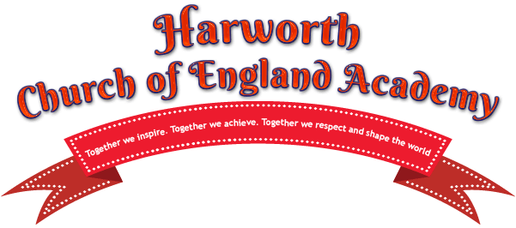

THANKYOU!!!!
Dear Parents/carers
Firstly- thank you for all your support last year with the various fundraising events that were held- as a result of all the support from yourselves, staff, children and local businesses we had an extremely successful smarties event and raffle and raised an amazing amount- meaning we are now in a fantastic position to be able to start helping school and enhancing the children’s school life.
We also hope all the children enjoyed visiting our pop up shop “ elfridges” and you all received a lovely surprise Christmas morning.
One of the first things we are going to do is support school in obtaining a new sound system- meaning the children will be able to put on their fantastic performances for us without the microphones failing and letting us hear them loud and clear.
We have also been able to fund the garden space at the top of the school drive- and envision this will be completed in the coming months and we have purchased bean bags for each classroom and the library for the children to use.
We are listening to the children and their ideas and an invitation has been sent school council to be able to build strong ties and understand what it is the pupils value about their school and support them in achieving this.
The next event we plan to hold is for Easter- Foundation and classes one and two will be able to enter an Easter bonnet parade- designing and making a hat – and then having the opportunity to parade for the judges in school. Classes 3,4,5 and 6 will be asked to paint hard boiled eggs – and again these will be judged to pick winners. The cost per entry will be £1 each and there will be two winners per class.
KS1 Easter bonnet parade will be on Thursday the 4th April 2019 and KS2 egg designs will be judged on Friday the 5th April 2019 at the retrospective coffee mornings. Get creative!
There will be no meeting in April due to key stage coffee mornings but please join us in May to start planning for the summer term.
Happi Group

